**UTS: Game Design Studio Two**

**Team Four**

Final Report

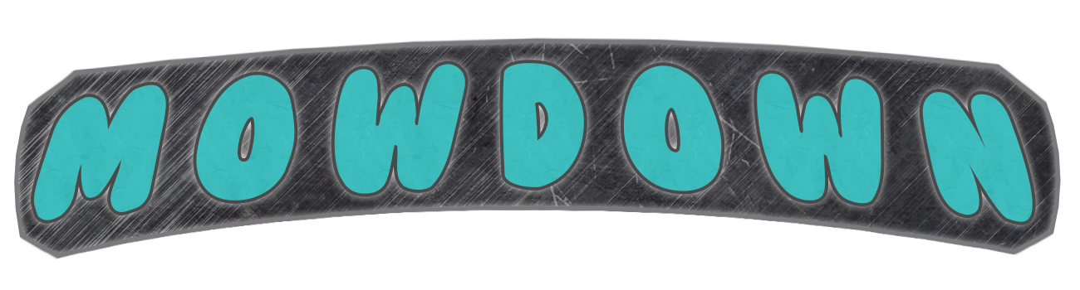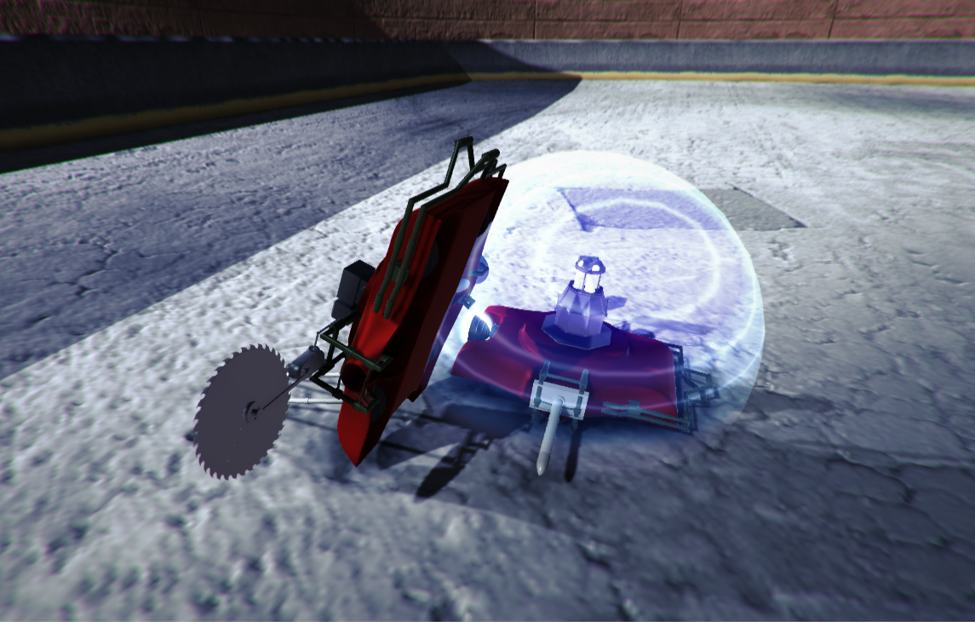

**Team Members:**

Matthew Carver –12028130

Deinyon Davies – 11688025

Robert McClelland –11743693

Dinh Bao Anh (Brendan) Vo – 11437237

Jesse Walker – 11729631

**Project Overview**

*Mowdown* is a ‘Demolition Derby’ or ‘Battle Bots’ style videogame, created by (in ascending alphanumeric order) Matthew Carver, Deinyon Davies, Dinh Bao Ahn (Brendan) Vo, Robert McClelland , and Jesse Walker.

Players customize one of several domestic **lawnmowers** by means of attaching defence appliances and weapons that have been unlocked and purchased by the player by means of in-game currency. Players compete against at least one autonomous opponent – a strategically formed battle-mower – as if both are controlled via Remote Control (R.C.).

**Sprints**

**Sprint 1:**

10 / AUG / 2015 – 23 / AUG / 2015

User Stories: 22

Estimated Time: 1,165 minutes

Completed: 1,165 minutes (100%)

Actual Time: 1,780 minutes

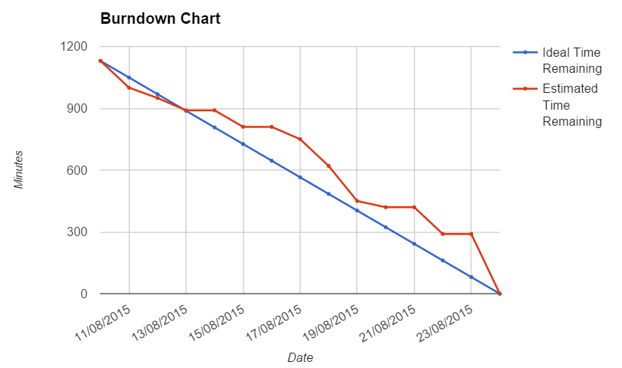

**Sprint 2:**

24 / AUG / 2015 – 06 / SEP / 2015

User Stories: 24

Estimated Time: 3,660 minutes

Completed: 2,510 minutes (69%)

Actual Time: 1,935 minutes

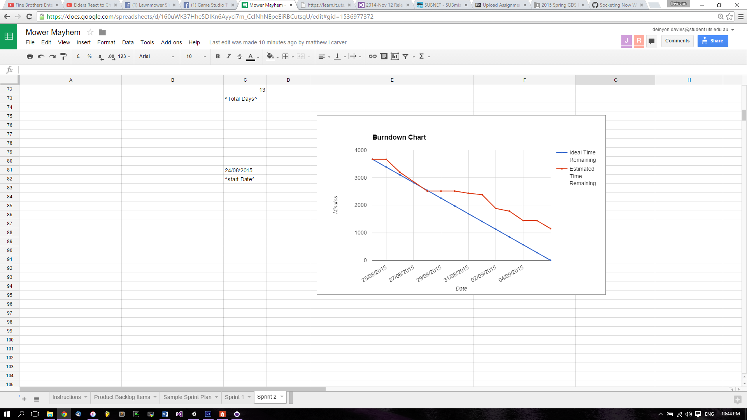

**Sprint 3:**

07 / SEP / 2015 – 20 / SEP / 2015

User Stories: 30

Estimated Time: 2,390 minutes

Completed: 2,130 minutes (89%)

Actual Time: 2,193 minutes

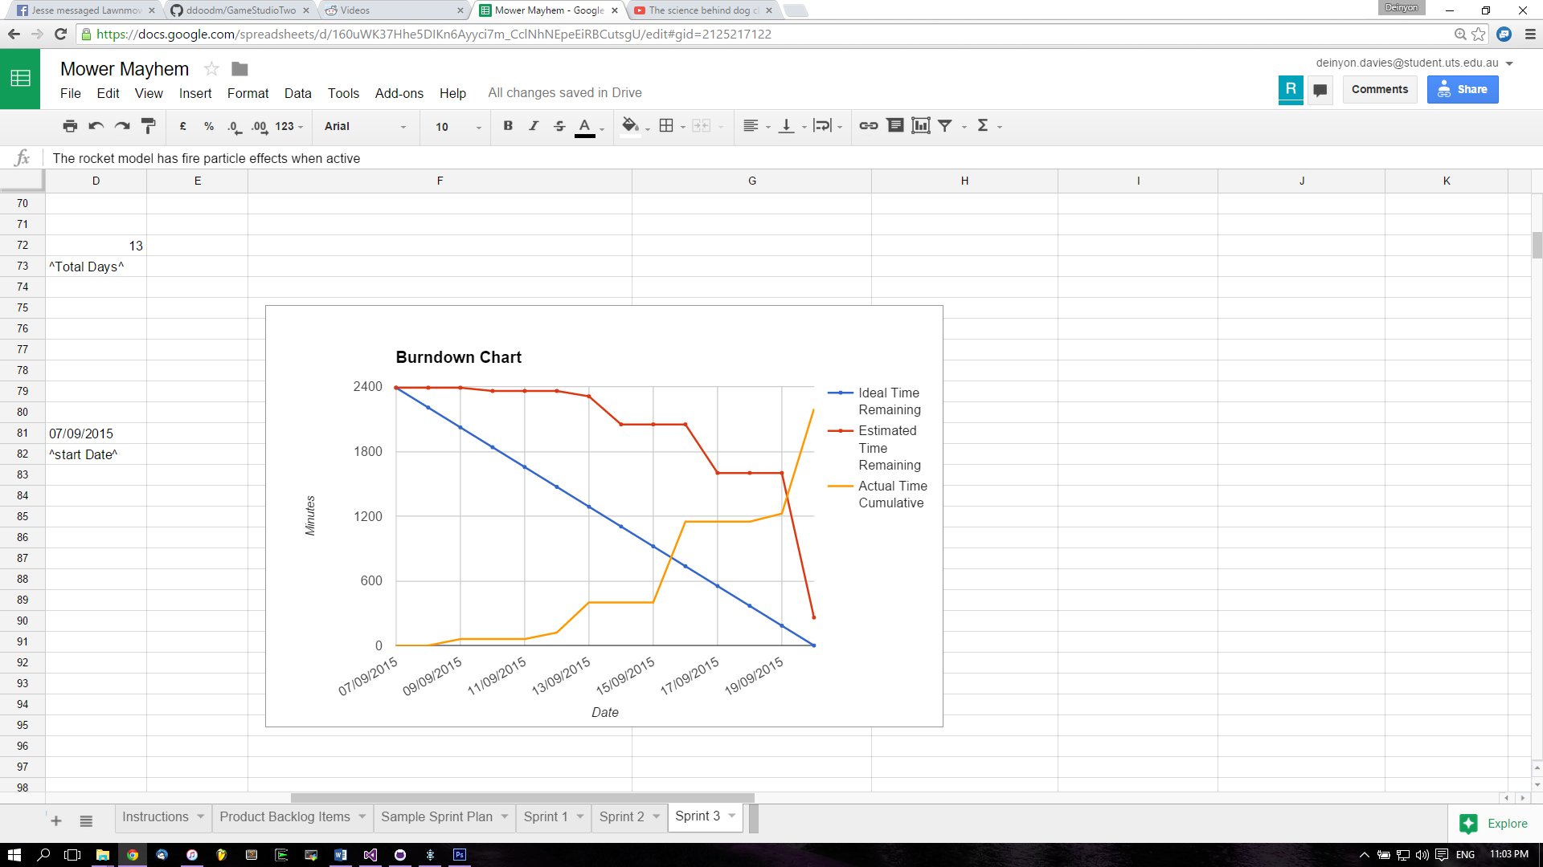

**Sprint 4:**

21 / SEP / 2015 – 11 / OCT / 2015

User Stories: 33

Estimated Time: 5,350 minutes

Completed: 4040 minutes (76%)

Actual Time: 2,835 minutes

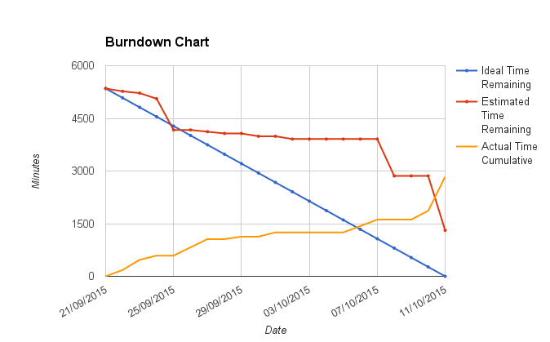

**Sprint 5:**

12 / OCT / 2015 – 25 / OCT / 2015

User Stories: 9

Estimated Time: 2,820 minutes

Completed: 1,480 minutes (52%)

Actual Time: 360 minutes

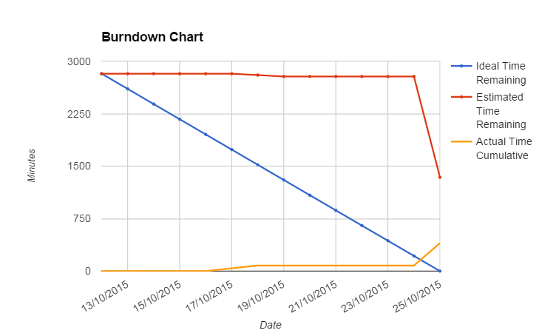

**Significant Contributions**

Most team members made significant contributions to many major components of the game, though each member specialized in at least one component. This section provides an overview of the team members’ specialized contributions to the project.

**Matthew Carver**

Designed and modelled all vehicle and attachment assets, as well as graphics and models for User Interfaces.

**Deinyon Davies**

Specialized in physics and Artificial Intelligence programming, and 3D Environment art, design and lighting. Made several critical programming contributions to many game components.

**Robert McClelland**

Designed and implemented game mechanics for vehicle attachments. Made major contributions to balance, and made numerous major programming contributions for many game components.

**Dinh Bao Anh (**Brendan**) Vo**

Contributed User Interface components and sound effects.

**Jesse Walker**

Made major contributions to User Interface design, game-loop control, and player control. Contributed to game design, game narrative and premise, and idea generation.

**Mowdown Post-Mortem**

*What is the one thing your team did really well? What evidence can you show for it?*

Analysis of the project’s Version Control statistics, correspondence and Sprint Sheets clearly demonstrates the team’s exceptional ability to work collaboratively. All team members made significant contributions to the project, most of which exceeded the expectations imposed on them by the group. Individual work was specialized, yet collaborative; most complex functionality was abstracted where possible to facilitate simple implementation of content by other team members when needed.

Team members made consistent contributions to the project across the entire duration of development, making a total of 328 commits to the project’s Master branch, and several commits to 11 other branches. See *Figure 1.0*.

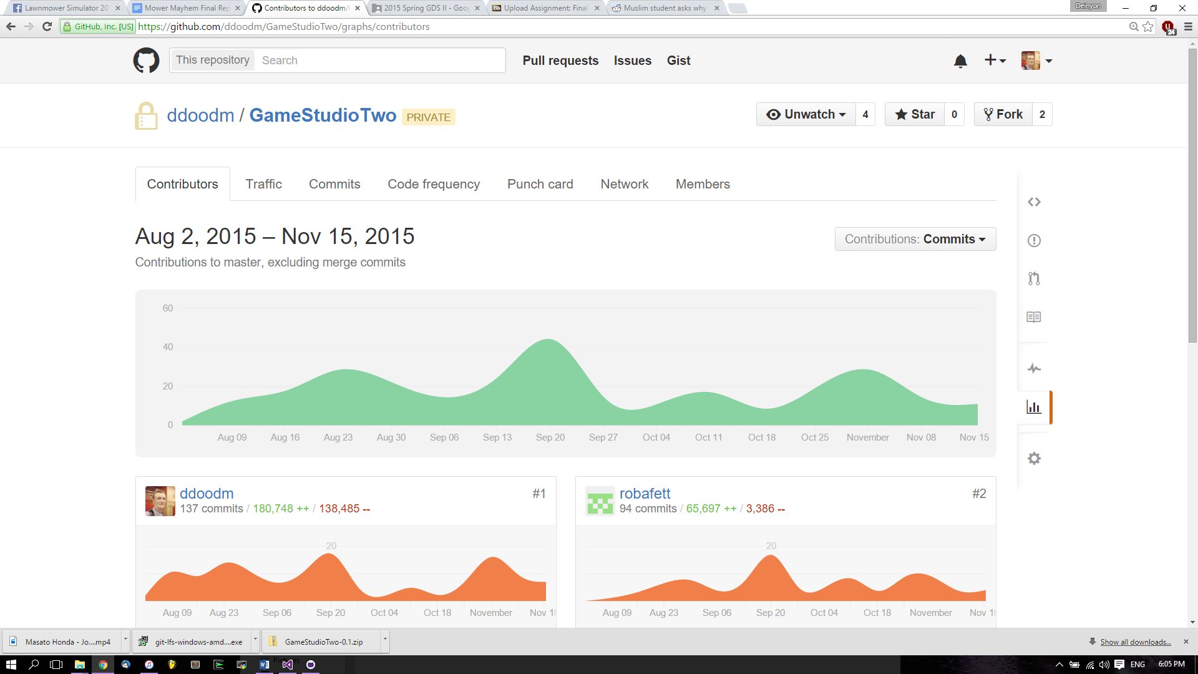

**Figure 1.0** *Contributions to Mowdown over the entire project duration*

*If you had another sprint to work on the game, what would be the 3 highest priority user stories*

If the team had one more sprint to work on this game the most important use case would be to add a tutorial to replace the constant tutorial messages in the game. Balancing would then be next on the list so as to deliver a favourable experience to the player. Lastly the team would attempt to implement the final mower chassis which has already been modelled and textured.

*Write one paragraph response to each of the assessment criteria. Provide evidence when possible to support your claims. Evidences can be part of the appendix for this document.*

*Timely and accurate sprint reports and presentations*

The team always endeavoured to provide an accurate representation of their completed work in all their sprint reports. Even when the team completed very little work in sprint five the team did not attempt to ‘rewrite history’ to deliver a favourable report rather the team expressed its difficulties and made moves to complete the uncompleted work in the following week when the team had more time.

*Evidence of iterative development with user testing*

The team conducted prototype testing with the public during sprint 2. Many things were suggested and most of them were added into sprint 3 or implemented in further sprints. Things added from user input include the addition of arrow key controls, environmental damage, and activateable attachments.

*Problem solving and communication within the team and with publisher*

Upon looking at the specifications of the game the team decided that a two dimensional perspective would be detrimental to the quality of the game. However as the publisher wanted some form of two dimensional perspective the team added a top-down camera that would adjust depending on the distance between the player and the bot. The camera would automatically adjust so that the bot and the player would always be in frame.

*Completeness and polish of the game*

The game exhibits its completeness and polish through the quality and quantity of its assets, and through the complex behaviours which emerge by means of the game system, and the user’s ability to make vital avatar-customization decisions to reflect their play-style.

The game sports detailed vehicle and attachment models, as well as detailed and realistic game environments, which undoubtedly contribute to the game’s sense of ‘polish’, and the player’s engagement. All game scenes have been carefully lit and colour graded to enhance the game’s aesthetics.

The game presents unique, animated user interfaces to the player, including the interactive ‘mobile phone’ interface, and the ’*auto-battle demo*’ menu interface.

*Creativity and interesting features*

The team wanted to provide a progressive experience for the player but not fall into the trap of most RPG’s where the upgrades would be purely mechanical. To work towards this endeavour the team made a new model for every attachment and almost all attachments had their own playstyle - the spike would encourage ramming your opponent whereas the flipper would encourage moving up to the opponent and strategically activating the attachment.

*Evidence that game is fun*

In all of our tests, testers expressed an interest in continuing to play the game. Despite testing periods being up to an hour testers would not become disinterested in the game and continued to give useful feedback and play the game. Furthermore upon completion of the trailer the team distributed the trailer to testers and all of them expressed interest in a chance to play the game again.

**Preferred Mark Distribution**

The team has determined that all group members have made significant and equal contributions, and as such, desires an equal mark distribution across all contributors.

Matthew Carver – **20%**

Deinyon Davies – **20%**

Robert McClelland – **20%**

Dinh Bao Anh (Brendan) Vo – **20%**

Jesse Walker – **20%**